**Analysis of Cognitive Walkthrough Data (Website):**

**Qualitative Analysis:**

**General opinion of how easy the site was to use:**

**Good Points:**

Fluid

The site feels complete, usage-wise

Side menu was easy to understand/navigate

**Bad Points:**

Confusion on naming of direction and data within tables on pages.

Working out data within a table when only an ID is available.

The side menu could be grouped better with consistent naming.

Overall least favourite feature was tables that only show the ID when retrieving/viewing information.

**Quantitative analysis:**

**How difficult the participant found the tasks:**

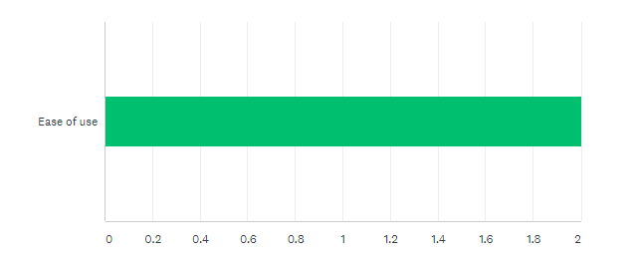

**Average level of ‘Control’ (How well the participant’s internal locus of control was supported(Tenenberg, n.d.)) felt by the participant when navigating the site:**

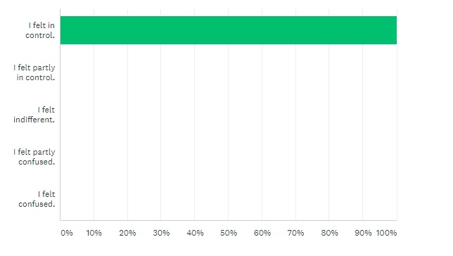

**Appendices:**

Tenenberg, J. (n.d.). *Shneiderman's Eight Golden Rules of Interface Design*. [online] Faculty.washington.edu. Available at: https://faculty.washington.edu/jtenenbg/courses/360/f04/sessions/schneidermanGoldenRules.html [Accessed 7 Mar. 2019].